ADITYA UNIVERSITY
School of Computing
Department of Artificial Intelligence and Machine Learning
DATA ANALYSIS ESSENTIALS
Certificate
This is to certify that the Cornerstone project work entitled “MOVIE RATING ANALYSIS SYSTEM”
is submitted by
M. Bhagya Sri (25B11AI720)
B. Jyostnavi (25B11AI081)
N. Swathi (26B21AI081)
K. Sri Bhargavi (26B21AI050)
in partial fulfilment of the requirements for the award of the B.Tech. degree in Artificial intelligence and machine learning the academic year 2026-2027.

Project Guide Head of the Department
B. Sai Venkata Ganesh Dr. K. Naga Bhargavi, Ph.D,
Assistant Professor Associate Professor & HOD
Department of AIML Department of AIML

CERTIFICATE

This is to certify that the project work entitled “MOVIE RATING ANALYSIS SYSTEM” is submitted by M.Bhagya Sri (25B11AI720), B. Jyotsnavi(25B11AI081), and N. Swathi (26B21AI081), K. Sri Bhargavi (26B21AI050) , in partial fulfilment of the requirements for the award of the B.Tech. degree in Artificial Intelligence and Machine Learning during the academic year 2026–2027.
The project has been carried out under the guidance of B. Sai Venkata Ganesh and demonstrates the application of data collection, data cleaning, exploratory data analysis, time-series analysis, and data visualization techniques.

Project Guide: B. Sai Venkata Ganesh
Department of AIML

DECLARATION

We hereby declare that the project entitled “MOVIE RATING ANALYSIS SYSTEM” is our original academic work and is submitted to ADITYA UNIVERSITY, Surampalem, in partial fulfilment of the requirements for the award of the B.Tech. degree in Artificial Intelligence and Machine Learning.

We further declare that this project work has not been submitted, either in full or in part, for the award of any degree or diploma in this or any other institution. We confirm that the work has been carried out with academic honesty and that the analysis and visualizations presented in this documentation are prepared for academic purposes.

Place: Surampalem

Date: 27-09-2026

Presented By :
M. Bhagya Sri (25B11AI720)
B. Jyostnavi (25B11AI081)
N. Swathi (26B21AI081)
K. Sri Bhargavi (26B21AI050)

ACKNOWLEDGEMENT

We express our sincere gratitude to our project guide, B. Sai Venkata Ganesh, for his valuable guidance, encouragement, and suggestions throughout the development of the Movie Rating Analysis System . His support helped us understand the practical application of data analysis concepts.

We also thank the Department of Artificial Intelligence and Machine Learning and the faculty members of Aditya University for providing the academic environment, laboratory facilities, and resources required to complete this project.

Finally, we thank our classmates, friends, and everyone who supported us directly or indirectly during the collection, processing, analysis, and presentation of the project.

ABSTRACT

The Movie Rating Analysis System is a data analysis project developed to collect, organize, process, analyze, and visualize movie-related data in a clear and understandable form. The project focuses on transforming raw movie data into meaningful information through data loading, data cleaning, exploratory data analysis, genre-wise analysis, rating analysis, and visualization.

Python is used as the primary programming language, with Pandas for data handling and analysis and Matplotlib for graphical visualization. The workflow includes examining the dataset, identifying missing or duplicate records, handling data inconsistencies, calculating average movie ratings, analyzing movie genres, comparing ratings, and generating summary statistics. Different visualizations, such as bar graphs, pie charts, line graphs, and histograms, are used to represent the results effectively.

The Movie Rating Analysis System helps users understand movie rating patterns, compare movies based on their ratings, identify popular genres, and analyze trends in movie preferences. The project demonstrates how data analysis and visualization techniques can transform large movie datasets into meaningful insights, making the information easier to understand and interpret.

TABLE OF CONTENTS

1 Introduction
1.1 Introduction to the Project
1.2 Problem Statement
1.3 Objectives of the Project
1.4 Scope of the Project
1.5 Motivation for the Project
1.6 Organisation of the Documentation
1.7 Overview of the Technologies Used
1.8 The Data Analysis Life Cycle
2 Dataset Description and Understanding
2.1 Dataset Source
2.2 Dataset Description
2.3 Features / Attributes
2.4 Target Variable
2.5 Dataset Statistics / Initial Exploration
2.6 Data Quality Assessment
2.7 Ethical Use and Licence of the Data
3 Data Preprocessing
3.1 Data Collection / Loading
3.2 Handling Missing Values
3.3 Handling Duplicate / Inconsistent Data
3.4 Date and Time Processing
3.5 Project-Specific Preprocessing
3.6 Summary of Preprocessing Steps
3.7 Data Transformation and Aggregation
3.8 Validation After Preprocessing
4 System Design and Methodology
4.1 Proposed Methodology
4.2 System Workflow / Architecture
4.3 Flowchart
4.4 Tools and Technologies Used
4.5 Analysis Methods Used
4.6 Software and Hardware Requirements
4.7 Modular Design
4.8 Dashboard Layout Design
5 Implementation
5.1 Development Environment
5.2 Dataset Loading and Exploration
5.3 Preprocessing Implementation
5.4 Exploratory Data Analysis
5.5 Time-Series and Geographic Analysis
5.6 Important Code Explanation
5.7 Testing and Validation
5.8 Common Errors and Their Solutions
6 Data Visualization and Results
6.1 Line Chart
6.2 Bar Graph
6.3 Pie Chart
6.4 Box Plot
6.5 Project-Specific Visualizations
6.6 Interpretation of Visualizations
6.7 Dashboard View
6.8 Preparing Charts for Black-and-White Printing

7 Analysis of Results
7.1 Analysis Approach
7.2 Observed Patterns
7.3 Result Interpretation
7.4 Discussion
7.5 Answers to the Analysis Questions
7.6 Comparison of Chart Types Used
7.7 Limitations of the Interpretation
8 Output Screenshots
8.1 Dataset Screenshots
8.2 Preprocessing Outputs
8.3 Visualization Outputs
8.4 Dashboard Outputs
9 Conclusion and Future Enhancements
9.1 Conclusion
9.2 Limitations
9.3 Future Enhancements
9.4 Learning Outcomes
9.5 Final Remarks
9.6 Summary of Objectives and Outcomes
10 References
11 Appendix – Source Code
Appendix B – Glossary of Terms

Chapter 1: Introduction

1.1 Introduction to the Project
The Movie Rating Analysis System analyzes a Netflix titles dataset containing information about movies and TV shows. The project focuses on understanding the structure and quality of the dataset and identifying patterns in content type, release years, ratings, countries, and genres.
The project follows a data analysis workflow consisting of data loading, data understanding, inspection, missing-value analysis, duplicate analysis, cleaning, preprocessing, exploratory analysis, visualization, and validation. The purpose is to transform raw tabular data into organized information that can be interpreted through numerical summaries and charts.

1.2 Problem Statement
A large entertainment dataset contains multiple attributes for movies and TV shows. Without systematic cleaning and analysis, it is difficult to understand the distribution of content, release-year patterns, ratings, countries, and genres. The project addresses this problem by applying a structured data analysis process to the Netflix Titles dataset.

1.3 Objectives of the Project
- Load and inspect the Netflix Titles dataset.
- Identify the size, columns, missing values, and duplicate records.
- Clean duplicate rows and handle selected missing values.
- Convert date_added into a proper datetime representation.
- Analyze Movies versus TV Shows.
- Analyze release-year and rating distributions.
- Identify top countries and genres represented in the dataset.
- Create visualizations using Matplotlib.
- Validate the cleaned dataset and save it as a CSV file.

1.4 Scope of the Project
The scope is limited to descriptive data analysis of the supplied Netflix Titles dataset. The project does not implement a recommendation engine, predictive rating model, machine-learning classifier, or forecasting system. The analysis concentrates on the attributes and operations implemented in the supplied Python code.

1.5 Motivation for the Project
Entertainment datasets contain useful information that can be understood through systematic data analysis. This project provides practical experience in loading real-world tabular data, identifying quality issues, cleaning data, transforming fields, calculating frequency distributions, and communicating findings through charts.

1.6 Organisation of the Documentation
The documentation is organized into chapters covering introduction, dataset understanding, preprocessing, methodology, implementation, visualization and results, analysis, output evidence, conclusion and future enhancements, references, and source code.

1.7 Overview of the Technologies Used
Technology | Purpose
Python | Programming language used for the complete analysis.
Pandas | Data loading, cleaning, transformation, counting, and aggregation.
NumPy | Imported for numerical/data-analysis support.
Matplotlib | Visualization of content types, years, ratings, countries, and genres.
Google Colab | Development and execution environment.
CSV | Dataset and cleaned-output storage format.

1.8 The Data Analysis Life Cycle
The project follows the sequence: Raw Dataset → Data Loading → Data Understanding → Data Inspection → Missing Value Analysis → Duplicate Analysis → Data Cleaning → Data Preprocessing → Data Analysis → Results. This sequence matches the workflow presented in the project review.

Chapter 2: Dataset Description and Understanding

2.1 Dataset Source
The project uses the supplied Netflix Titles CSV dataset, provided as netflix_titles.csv for this documentation. The file is loaded into a Pandas DataFrame using pandas.read_csv().

2.2 Dataset Description
The raw dataset contains 8,812 records and 12 columns. It includes information about movies and TV shows, directors, cast, countries, dates added, release years, ratings, duration, genres/categories, and descriptions.

2.3 Features / Attributes
Attribute | Description
show_id | Identifier of the title.
type | Content type such as Movie or TV Show.
title | Title name.
director | Director information.
cast | Cast information.
country | Country or countries associated with the title.
date_added | Date the title was added.
release_year | Release year of the title.
rating | Content rating.
duration | Duration information.
listed_in | Genre/category information.
description | Description of the title.

2.4 Target Variable
The project does not define a single target variable because it is a descriptive data analysis project rather than a supervised machine-learning task. The analysis uses multiple fields such as type, release_year, rating, country, and listed_in.

2.5 Dataset Statistics / Initial Exploration
Measure | Value
Rows before cleaning | 8,812
Columns | 12
Duplicate rows | 5
Total missing values before cleaning | 4314
Rows after duplicate removal | 8807
Final duplicate rows | 0

The raw dataset contains 4,314 missing cells in total and five completely duplicated rows. These values were obtained directly from the supplied CSV.

2.6 Data Quality Assessment
Column | Missing Values
show_id | 0
type | 0
title | 0
director | 2637
cast | 827
country | 833
date_added | 10
release_year | 0
rating | 4
duration | 3
listed_in | 0
description | 0

The largest missing-value counts occur in director, country, and cast. The code handles missing values in director, cast, country, date_added, rating, and duration by filling them with “Unknown”.

2.7 Ethical Use and Licence of the Data
The documentation does not assert a specific dataset licence because no licence information was supplied with the files used for this task. The dataset should therefore be used according to the terms under which it was originally obtained and any applicable institutional or platform requirements.

Chapter 3: Data Preprocessing

3.1 Data Collection / Loading
The dataset is uploaded through Google Colab's file-upload interface and read using Pandas.
from google.colab import files
uploaded = files.upload()
file_name = list(uploaded.keys())[0]
df = pd.read_csv(file_name)

3.2 Handling Missing Values
Missing values are first measured using df.isnull().sum(). Selected columns are then filled with the text value “Unknown”.
missing_values = df.isnull().sum()
df['director'] = df['director'].fillna('Unknown')
df['cast'] = df['cast'].fillna('Unknown')
df['country'] = df['country'].fillna('Unknown')
df['date_added'] = df['date_added'].fillna('Unknown')
df['rating'] = df['rating'].fillna('Unknown')
df['duration'] = df['duration'].fillna('Unknown')

3.3 Handling Duplicate / Inconsistent Data
The raw dataset contains 5 duplicate rows. The code removes them using drop_duplicates(), reducing the dataset from 8,812 to 8,807 records.
duplicate_count = df.duplicated().sum()
df = df.drop_duplicates()
print(df.shape)

3.4 Date and Time Processing
The date_added field is converted using pandas.to_datetime() with errors='coerce'. This allows valid date strings to become datetime values while invalid or non-date entries become missing datetime values.
df['date_added'] = pd.to_datetime(
df['date_added'],
errors='coerce'
)

3.5 Project-Specific Preprocessing
The project performs two main preprocessing operations: replacement of missing values in selected columns and conversion of date_added into datetime format. Country and genre fields are later split on commas for frequency analysis.

3.6 Summary of Preprocessing Steps
- Loaded the CSV file into a DataFrame.
- Inspected dataset dimensions and columns.
- Measured missing values.
- Counted duplicate rows.
- Removed duplicate rows.
- Filled selected missing fields with “Unknown”.
- Converted date_added to datetime.
- Checked final shape, missing values, and duplicates.

3.7 Data Transformation and Aggregation
For country and genre analysis, comma-separated values are split into separate entries, expanded using explode(), whitespace is removed with strip(), and frequencies are calculated using value_counts().
country_count = (
df['country']
.str.split(',')
.explode()
.str.strip()
.value_counts()
)
genre_count = (
df['listed_in']
.str.split(',')
.explode()
.str.strip()
.value_counts()
)

3.8 Validation After Preprocessing
After duplicate removal and missing-value filling, the DataFrame contains 8,807 rows and 12 columns and has zero duplicate rows. However, after date_added is converted with errors='coerce', the ten original missing date_added entries become NaT values. Therefore, the exact supplied code's final missing-value check is expected to report 10 missing datetime cells rather than zero.

Chapter 4: System Design and Methodology

4.1 Proposed Methodology
The methodology is a sequential descriptive data-analysis pipeline. Each stage prepares the dataset for the next stage and produces either a validation result, a frequency summary, or a visualization.

4.2 System Workflow / Architecture
Raw Dataset → Loading → Understanding → Inspection → Missing Value Analysis → Duplicate Analysis → Cleaning → Preprocessing → Exploratory Analysis → Visualization → Final Validation → Cleaned CSV

4.3 Flowchart

RAW DATA SET

DATA LOADING
↓

↓
DATA UNDERSTANDING

↓
DATA INSPECTION

↓
MISSING VALUE ANALYSIS
↓
DUPLICATE ANALYSIS
↓
DATA CLEANING
↓
DATA PREPROCESSING
↓
DATA ANALYSIS
↓
RESULTS

4.4 Tools and Technologies Used
Tool | Role in Project
Python | Core implementation
Pandas | DataFrame operations
NumPy | Imported numerical library
Matplotlib | Graphs
Google Colab | Execution environment

4.5 Analysis Methods Used
- value_counts() for categorical frequency analysis.
- sort_index() for release-year ordering.
- str.split(), explode(), and strip() for multi-valued country/genre fields.
- Bar charts for categorical comparisons.
- Line chart for release-year trend.
- head(10) for top-country and top-genre summaries.

4.6 Software and Hardware Requirements
Requirement | Specification
Software | Google Colab / Python environment
Libraries | Pandas, NumPy, Matplotlib
Input | Netflix Titles CSV file
Output | Cleaned CSV and analysis charts
Hardware | A computer capable of running a browser and Google Colab

4.7 Modular Design
The code is logically divided into modules for imports, data loading, understanding, inspection, missing-value analysis, duplicate analysis, cleaning, preprocessing, content analysis, release-year analysis, rating analysis, country analysis, genre analysis, final checks, saving, and summary.

4.8 Dashboard Layout Design
The supplied project is a code-based analysis and visualization workflow rather than an interactive dashboard implementation. The review presentation communicates results using individual charts. No interactive dashboard framework is implemented in the supplied code.

Chapter 5: Implementation

5.1 Development Environment
The project is implemented in Python using Google Colab. The dataset is uploaded through the Colab file interface and processed in a Pandas DataFrame.

5.2 Dataset Loading and Exploration
import pandas as pd
import numpy as np
from google.colab import files
uploaded = files.upload()
file_name = list(uploaded.keys())[0]
df = pd.read_csv(file_name)
print("Dataset loaded successfully")
The DataFrame shape and column names are then displayed to establish the initial dataset structure.

5.3 Preprocessing Implementation
The preprocessing implementation removes duplicate rows, fills selected missing values, and converts date_added to datetime. These operations prepare the data for subsequent frequency analysis and visualization.

5.4 Exploratory Data Analysis
The exploratory analysis calculates distributions for content type, release year, rating, country, and genre. The results are used to identify the most frequent categories and major patterns in the dataset.

5.5 Time-Series and Geographic Analysis
Release-year analysis uses the release_year field to construct an ordered line chart. Country analysis treats comma-separated country values as multiple country entries and calculates the most frequent countries.

5.6 Important Code Explanation

Content type
type_count = df['type'].value_counts()
print(type_count)

Release year
release_year_count = df['release_year'].value_counts().sort_index()
print(release_year_count)

Rating
rating_count = df['rating'].value_counts()
print(rating_count)

Countries
country_count = (
df['country'].str.split(',').explode().str.strip().value_counts()
)

Genres
genre_count = (
df['listed_in'].str.split(',').explode().str.strip().value_counts()
)

5.7 Testing and Validation
The project performs final validation by printing the final dataset shape, total missing values, total duplicate rows, and the first five cleaned records. The cleaned DataFrame is then saved as cleaned_netflix_titles.csv.

5.8 Common Errors and Their Solutions
Potential Issue | Handling in Project
File not uploaded | Google Colab upload step is used before read_csv.
Missing text values | Selected fields are filled with “Unknown”.
Duplicate records | drop_duplicates() removes complete duplicate rows.
Invalid date strings | to_datetime(..., errors='coerce') prevents conversion failure.
Multiple countries/genres in one cell | split + explode + strip separates and counts entries.

Chapter 6: Data Visualization and Results

6.1 Line Chart
The release-year analysis uses a line chart to show the number of titles associated with each release year. The chart is appropriate for viewing changes across an ordered year sequence.

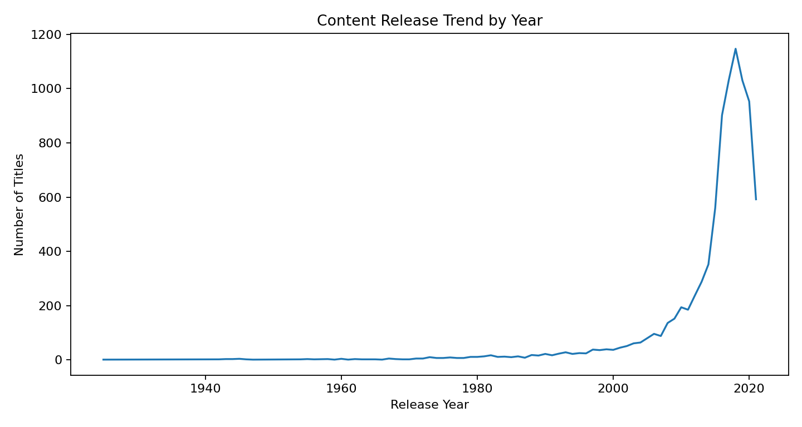
Figure 6.1: Content Release Trend by Year

6.2 Bar Graph
Bar graphs are used for categorical comparisons such as Movies versus TV Shows, rating distribution, top countries, and top genres.
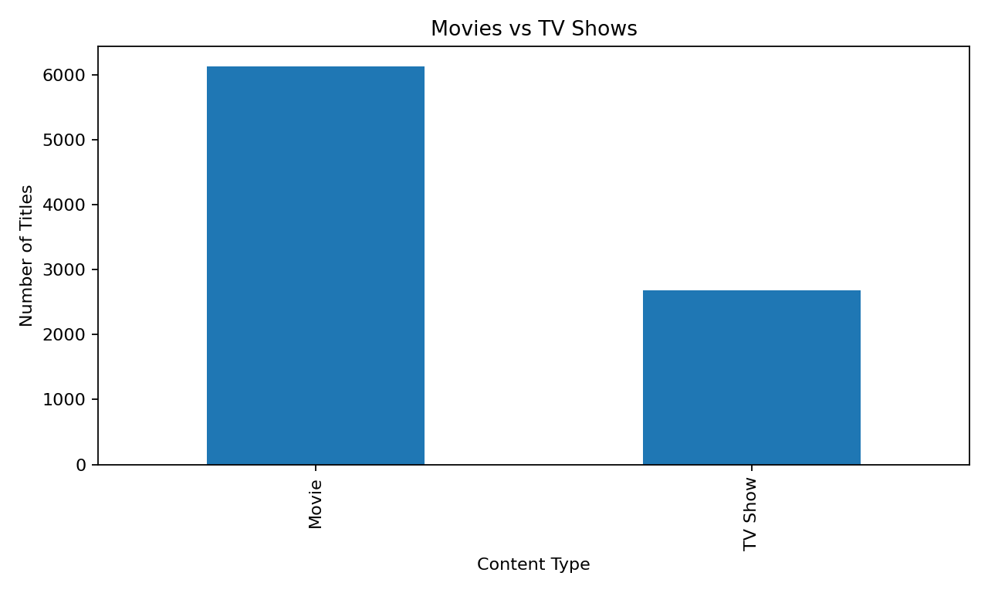
Figure 6.2: Movies vs TV Shows
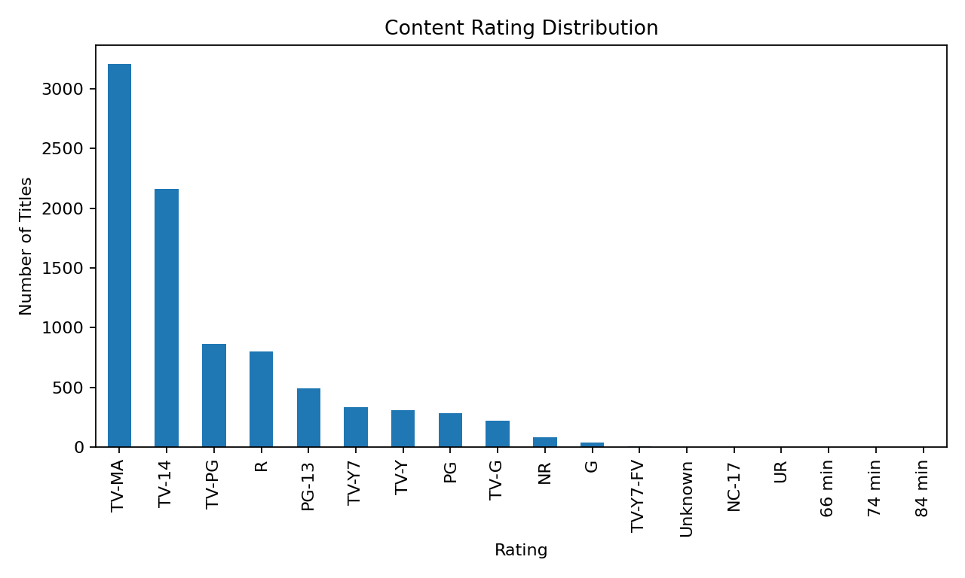
Figure 6.3: Content Rating Distribution

6.3 Pie Chart
No pie-chart implementation is present in the supplied Python code. Therefore, no pie-chart result is claimed for this project.

6.4 Box Plot
No box-plot implementation is present in the supplied Python code. Therefore, no box-plot result is claimed for this project.

6.5 Project-Specific Visualizations
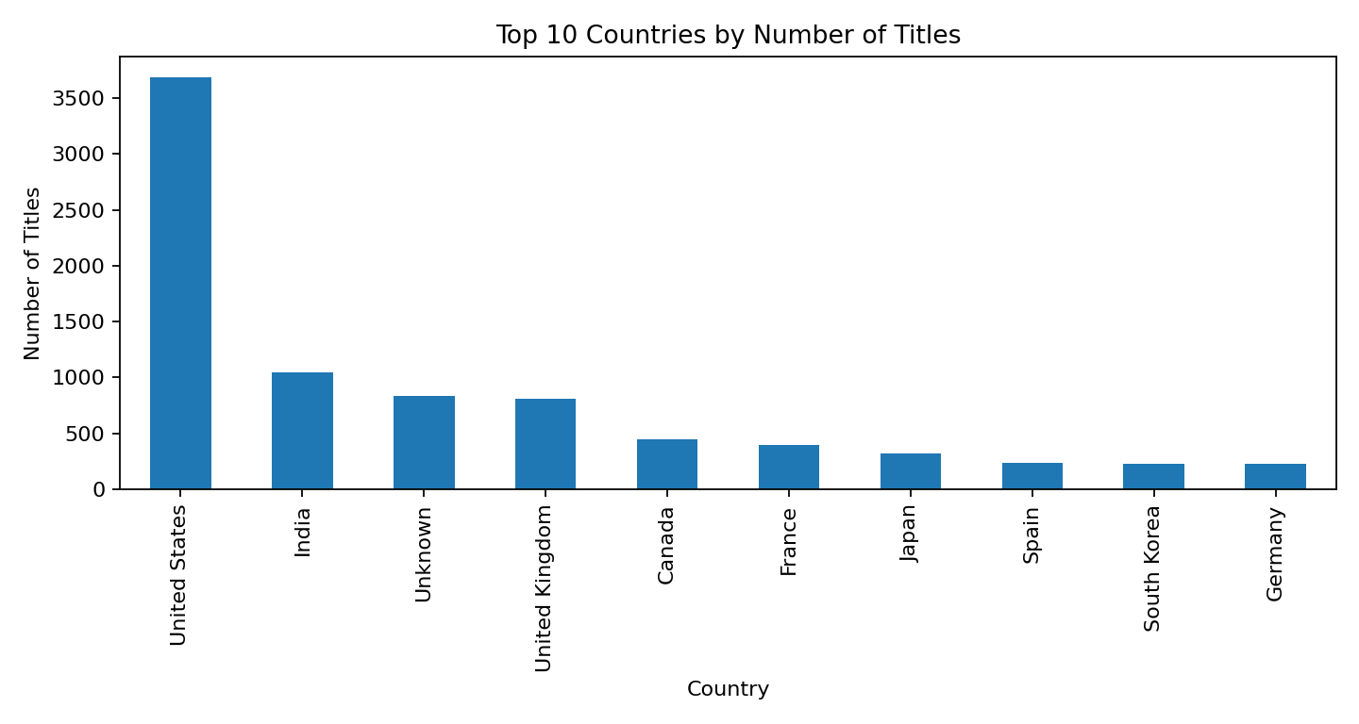
Figure 6.4: Top 10 Countries by Number of Titles

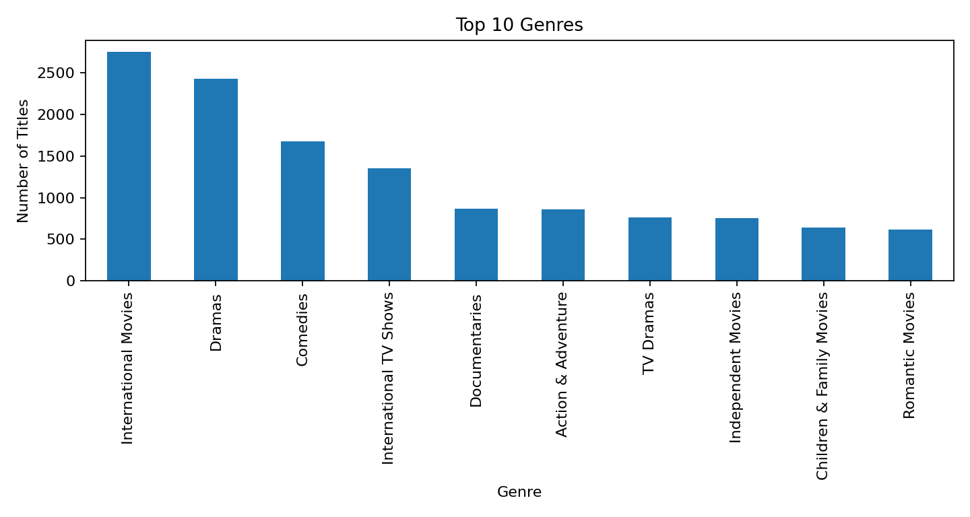
Figure 6.5: Top 10 Genres

6.6 Interpretation of Visualizations
The content-type analysis shows 6,131 Movies and 2,676 TV Shows in the cleaned dataset. The rating distribution is led by TV-MA with 3,207 titles. In the exploded country counts, United States has the highest frequency, while International Movies is the most frequent listed category.

6.7 Dashboard View
The supplied implementation does not create an interactive dashboard. Instead, the project presents individual Matplotlib visualizations. The documentation therefore treats the visualization set as the project output rather than claiming an interactive dashboard.

6.8 Preparing Charts for Black-and-White Printing
For printed documentation, chart titles, axis labels, readable font sizes, and clear category ordering should be preserved. The generated charts can be printed in grayscale, although the supplied code does not explicitly configure a black-and-white style.

Chapter 7: Analysis of Results

7.1 Analysis Approach
The analysis is descriptive. Frequency counts and ordered counts are calculated from cleaned data, and visualizations are used to communicate the resulting distributions.

7.2 Observed Patterns
Analysis | Observed Result
Content type | Movies: 6,131; TV Shows: 2,676
Top rating | TV-MA (3,207)
Top country | United States (3,690 exploded entries)
Top genre | International Movies (2,752 exploded entries)
Highest release-year count | 2018 (1,147 titles)

7.3 Result Interpretation
The cleaned dataset contains substantially more Movies than TV Shows. The frequency analysis also shows that certain ratings, countries, and genres occur more often than others. Release-year counts provide a year-wise view of the titles represented in the dataset.

7.4 Discussion
The project demonstrates how basic descriptive analysis can convert a large CSV file into interpretable summaries. The country and genre analyses are especially dependent on splitting multi-valued cells, so their counts represent exploded entries rather than a single mutually exclusive category per title.

7.5 Answers to the Analysis Questions
Question | Answer
What is the content-type distribution? | The cleaned dataset contains 6,131 Movies and 2,676 TV Shows.
Which rating occurs most frequently? | TV-MA is the most frequent rating with 3,207 titles.
Which country has the highest count? | United States has the highest exploded country count.
Which genre/category is most frequent? | International Movies is the most frequent listed category.
Which release year has the highest count? | 2018 has the highest number of titles (1,147).

7.6 Comparison of Chart Types Used
Chart | Purpose
Bar chart | Compare discrete categories such as content types, ratings, countries, and genres.
Line chart | Show ordered release-year counts and trends across years.
Pie chart | Not implemented in the supplied code.
Box plot | Not implemented in the supplied code.

7.7 Limitations of the Interpretation
The project is descriptive and does not establish causal relationships. Country and genre counts are based on exploded comma-separated values. The code also converts missing date_added entries to NaT after the initial fill, so the final missing-value count differs from the presentation's simplified after-cleaning value of zero.

Chapter 8: Output Screenshots

8.1 Dataset Screenshots
The original dataset contains 8,812 rows and 12 columns. The implementation uses df.head() and df.info() to inspect the first five records and data types/non-null information.

8.2 Preprocessing Outputs
Validation | Observed
Initial shape | 8,812 × 12
Duplicate rows before cleaning | 5
Rows after duplicate removal | 8,807
Duplicate rows after cleaning | 0
Original missing cells | 4314
Missing cells after datetime coercion | 10

8.3 Visualization Outputs
Figure 8.1: Movies vs TV Shows output

Figure 8.2: Release-year trend output

Figure 8.3: Rating distribution output

Figure 8.4: Top countries output

Figure 8.5: Top genres output

8.4 Dashboard Outputs
No interactive dashboard output is implemented in the supplied source code. The project output consists of console summaries and Matplotlib charts.

Chapter 9: Conclusion and Future Enhancements

9.1 Conclusion
The Movie Rating Analysis System demonstrates a complete descriptive data-analysis workflow using Python, Pandas, NumPy, and Matplotlib. The Netflix Titles dataset was successfully loaded, inspected, cleaned, preprocessed, analyzed, and visualized.
The project identified 5 duplicate rows and reduced the dataset from 8,812 to 8,807 records. It analyzed content type, release year, rating, country, and genre distributions and generated corresponding visualizations.

9.2 Limitations
- The project is descriptive and does not perform predictive modeling.
- No recommendation system is implemented.
- No interactive dashboard framework is implemented in the supplied code.
- Country and genre values are multi-valued and are counted after splitting/exploding.
- The exact code leaves ten NaT values after date conversion because errors='coerce' is used on the ten missing date entries.

9.3 Future Enhancements
- Build an interactive dashboard using a dashboard framework.
- Add more detailed title-level and duration analysis.
- Perform temporal analysis using date_added after handling missing dates explicitly.
- Add filters for country, rating, content type, and genre.
- Develop recommendation or predictive components as a separate extension.
- Add automated data-quality reports and validation tests.

9.4 Learning Outcomes
- Practical use of Pandas DataFrames.
- Understanding missing values and duplicate records.
- Data cleaning and preprocessing.
- Frequency-based exploratory analysis.
- Handling comma-separated multi-valued fields.
- Creating bar and line charts using Matplotlib.
- Working with CSV files in Google Colab.

9.5 Final Remarks
The project provides a practical foundation for further data-analysis work. The workflow can be extended with additional analysis, stronger validation, and interactive visualization while retaining the same basic data-processing pipeline.

9.6 Summary of Objectives and Outcomes

Objective | Outcome
Load and inspect data | Completed
Identify data-quality issues | Completed
Remove duplicates | 5 removed
Handle selected missing values | Completed; date conversion later produces 10 NaT
Analyze content types | Completed
Analyze release years and ratings | Completed
Analyze countries and genres | Completed
Create visualizations | Completed
Save cleaned dataset | Implemented as cleaned_netflix_titles.csv

Chapter 10: References

- Kaggle, “Netflix Movies and TV Shows Dataset,” https://www.kaggle.com/datasets/shivamb/netflix-shows (Dataset downloaded from Kaggle for the Movie Rating Analysis System project).
- Python Software Foundation, Python Documentation, https://docs.python.org/3/.
- Pandas Development Team, Pandas Documentation, https://pandas.pydata.org/docs/.
- NumPy Developers, NumPy Documentation, https://numpy.org/doc/stable/.
- Matplotlib Development Team, Matplotlib Documentation, https://matplotlib.org/stable/.
- McKinney, W., Python for Data Analysis, O’Reilly Media.
- Netflix Movies and TV Shows Dataset, Kaggle, used as a reference for exploring movie and TV show information.

Chapter 11: Appendix – Source Code

# IMPORT LIBRARIES
import pandas as pd
import numpy as np
# DATA LOADING
from google.colab import files
uploaded = files.upload()
file_name = list(uploaded.keys())[0]
df = pd.read_csv(file_name)
print("Dataset loaded successfully")
# DATA UNDERSTANDING
print("Number of Rows:", df.shape[0])
print("Number of Columns:", df.shape[1])
print("\nColumn Names:")
print(df.columns.tolist())
# DATA INSPECTION
print("First 5 Records:")
display(df.head())
print("\nDataset Information:")
df.info()
# MISSING VALUE ANALYSIS
missing_values = df.isnull().sum()
print("Missing Values in Each Column:")
print(missing_values)
# DUPLICATE VALUE ANALYSIS
duplicate_count = df.duplicated().sum()
print("Number of Duplicate Rows:", duplicate_count)
# DATA CLEANING – REMOVE DUPLICATES
df = df.drop_duplicates()
print("Duplicate rows removed successfully")
print("Number of Duplicate Rows:", df.duplicated().sum())
print("Updated Dataset Shape:", df.shape)
# DATA CLEANING – HANDLE MISSING VALUES
df['director'] = df['director'].fillna('Unknown')
df['cast'] = df['cast'].fillna('Unknown')
df['country'] = df['country'].fillna('Unknown')
df['date_added'] = df['date_added'].fillna('Unknown')
df['rating'] = df['rating'].fillna('Unknown')
df['duration'] = df['duration'].fillna('Unknown')
print("Missing values handled successfully")
print("\nMissing Values After Cleaning:")
print(df.isnull().sum().sum())
# DATA PREPROCESSING
df['date_added'] = pd.to_datetime(
df['date_added'],
errors='coerce'
)
print("Date format converted successfully")
print("\nData Types:")
print(df.dtypes)
# MOVIES VS TV SHOWS ANALYSIS
type_count = df['type'].value_counts()
print("Content Type Analysis:")
print(type_count)
# RELEASE YEAR ANALYSIS
release_year_count = df['release_year'].value_counts().sort_index()
print("Release Year Analysis:")
print(release_year_count)
# RATING ANALYSIS
rating_count = df['rating'].value_counts()
print("Rating Analysis:")
print(rating_count)
# MOVIES VS TV SHOWS GRAPH
type_count.plot(
kind='bar',
title='Movies vs TV Shows',
xlabel='Content Type',
ylabel='Number of Titles'
)
# RELEASE YEAR TREND GRAPH
release_year_count.plot(
kind='line',
title='Content Release Trend by Year',
xlabel='Release Year',
ylabel='Number of Titles',
figsize=(10, 5)
)
# RATING DISTRIBUTION GRAPH
rating_count.plot(
kind='bar',
title='Content Rating Distribution',
xlabel='Rating',
ylabel='Number of Titles',
figsize=(10, 5)
)
# TOP 10 COUNTRIES
country_count = (
df['country']
.str.split(',')
.explode()
.str.strip()
.value_counts()
)
print("Top 10 Countries:")
print(country_count.head(10))
country_count.head(10).plot(
kind='bar',
title='Top 10 Countries by Number of Titles',
xlabel='Country',
ylabel='Number of Titles',
figsize=(10, 5)
)
# TOP 10 GENRES
genre_count = (
df['listed_in']
.str.split(',')
.explode()
.str.strip()
.value_counts()
)
print("Top 10 Genres:")
print(genre_count.head(10))
genre_count.head(10).plot(
kind='bar',
title='Top 10 Genres',
xlabel='Genre',
ylabel='Number of Titles',
figsize=(10, 5)
)
# FINAL DATA CHECK
print("Final Dataset Shape:", df.shape)
print("\nTotal Missing Values:")
print(df.isnull().sum().sum())
print("\nTotal Duplicate Rows:")
print(df.duplicated().sum())
print("\nFirst 5 Records of Cleaned Dataset:")
display(df.head())
# SAVE CLEANED DATASET
df.to_csv("cleaned_netflix_titles.csv", index=False)
print("Cleaned dataset saved successfully!")
# FINAL ANALYSIS SUMMARY
print("FINAL DATASET SUMMARY")
print("---------------------")
print("Total Titles:", len(df))
print("Total Columns:", len(df.columns))
print("\nContent Type:")
print(df['type'].value_counts())
print("\nTop 5 Ratings:")
print(df['rating'].value_counts().head(5))
print("\nTop 5 Genres:")
print(genre_count.head(5))
print("\nTop 5 Countries:")
print(country_count.head(5))

Appendix B – Glossary of Terms

Term | Meaning
CSV | Comma-Separated Values file format.
DataFrame | Two-dimensional Pandas data structure used to store tabular data.
EDA | Exploratory Data Analysis.
NaN | Missing numerical/object value representation.
NaT | Missing datetime value produced by datetime conversion.
value_counts() | Pandas method for frequency counting.
explode() | Pandas operation that expands list-like or separated entries into rows.
Matplotlib | Python visualization library used by the project.
Preprocessing | Operations performed to prepare data for analysis.
Duplicate | Repeated complete record in the dataset.

TEAM CONTRIBUTION

Team Member | Contribution
M. Bhagya Sri (25B11AI720) | Code implementation, dataset loading, data exploration, preprocessing, project code execution, and screen sharing.
B. Jyostnavi (25B11AI081) | Project analysis, PPT preparation, organizing project content, presentation coordination, reviewing outputs, and arranging content.
N. Swathi (26B21AI081) | Data analysis and calculations; identifying movie counts, unique movie names, repeated movie names, and important results.
K. Sri Bhargavi (26B21AI050) | Dataset collection and preparation; checking missing values, duplicate records, and overall data quality.

Detailed Project Profile

The Movie Rating Analysis System is a structured data-analysis project developed using the Netflix Titles dataset. The purpose of this project is to demonstrate the complete process of working with a real-world CSV dataset, beginning with loading and understanding the raw data and ending with visual analysis and a cleaned output file.
The project is intentionally descriptive. It does not attempt to predict ratings or recommend titles. Instead, it focuses on what is present in the supplied dataset and communicates the distribution of titles across content type, release year, ratings, countries, and genres.
Project Element | Details
Project Title | Movie Rating Analysis System
Dataset | Netflix Titles dataset
Input Format | CSV
Programming Language | Python
Primary Library | Pandas
Visualization | Matplotlib
Execution Environment | Google Colab
Output | Charts and cleaned_netflix_titles.csv

Project Background
Modern streaming platforms maintain large collections of content with many descriptive attributes. A tabular dataset containing these attributes can be examined to understand what kinds of content are represented and how the records are distributed.
The supplied Netflix Titles dataset contains fields covering identity, type, people involved, country, date information, release year, rating, duration, categories, and description. These fields provide a suitable foundation for practicing data inspection, cleaning, transformation, aggregation, and visualization.

Need for Data Analysis
- Raw datasets may contain duplicate records.
- Several attributes may contain missing values.
- Some columns contain multiple comma-separated values.
- Different fields require different analytical techniques.
- Visual summaries make categorical and time-ordered patterns easier to interpret.

Project Problem Analysis
The main problem addressed by the project is the transformation of a raw entertainment dataset into a clean and interpretable analytical dataset. A direct inspection of thousands of records does not easily reveal the distribution of content.
Problem | Project Response
Large number of records | Use DataFrame summaries and frequency counts.
Duplicate records | Identify and remove duplicate rows.
Missing text attributes | Fill selected fields with Unknown.
Date representation | Convert date_added using to_datetime.
Multiple countries per title | Split and explode country values.
Multiple genres per title | Split and explode listed_in values.
Difficulty comparing categories | Use bar charts.
Year-wise distribution | Use an ordered line chart.

Project Objectives in Detail

- Load the supplied CSV dataset into a Pandas DataFrame.
- Determine the number of records and columns.
- Inspect column names and sample records.
- Measure missing values column by column.
- Measure complete duplicate rows.
- Remove duplicate records.
- Replace selected missing values with a consistent placeholder.
- Convert date_added into datetime representation.
- Calculate content-type frequencies.
- Calculate release-year frequencies.
- Calculate rating frequencies.
- Extract and count country entries.
- Extract and count genre entries.
- Generate clear visualizations.
- Perform final validation and save the cleaned dataset.

Dataset Structure
The dataset contains 12 attributes. Each attribute represents a different aspect of a title. The structure allows both record-level inspection and grouped analysis.
No. | Column | Role in Analysis
1 | show_id | Record identifier
2 | type | Movie / TV Show classification
3 | title | Title name
4 | director | Director information
5 | cast | Cast information
6 | country | Country information
7 | date_added | Date added information
8 | release_year | Release-year analysis
9 | rating | Rating distribution
10 | duration | Duration information
11 | listed_in | Genre/category analysis
12 | description | Title description

Initial Dataset Exploration
Initial exploration is performed before cleaning so that the original condition of the dataset can be documented. The code uses shape, columns, head, and info operations.
print("Number of Rows:", df.shape[0])
print("Number of Columns:", df.shape[1])
print(df.columns.tolist())
display(df.head())
df.info()

The supplied dataset contains 8,812 rows and 12 columns. The first five records are displayed to confirm the general structure, while df.info() provides information about column types and non-null counts.

Missing Value Assessment

Missing-value assessment is an important data-quality step. The project first calculates missing values independently for every column.
missing_values = df.isnull().sum()
print("Missing Values in Each Column:")
print(missing_values)

Column | Missing Values
show_id | 0
type | 0
title | 0
director | 2637
cast | 827
country | 833
date_added | 10
release_year | 0
rating | 4
duration | 3
listed_in | 0
description | 0

The assessment shows that director contains the largest number of missing entries, followed by country and cast. This information guides the subsequent cleaning operation.

Duplicate Record Assessment

Duplicate records are checked using the Pandas duplicated() method. A complete duplicate means that the entire row repeats an existing row.
duplicate_count = df.duplicated().sum()
print("Number of Duplicate Rows:", duplicate_count)

The supplied dataset contains 5 duplicate rows. The project removes these rows before continuing with the analysis.
df = df.drop_duplicates()
print("Updated Dataset Shape:", df.shape)
print("Number of Duplicate Rows:", df.duplicated().sum())

After duplicate removal, the working dataset contains 8,807 records and 12 columns.

Missing Value Cleaning Strategy

The project uses a simple and transparent strategy for selected missing text fields: replacing null values with the string Unknown. This avoids leaving blank entries in fields used for categorical analysis.
Field | Replacement
director | Unknown
cast | Unknown
country | Unknown
date_added | Unknown
rating | Unknown
duration | Unknown

This approach is suitable for descriptive analysis because it preserves the fact that the original value was unavailable instead of inventing a specific director, actor, country, rating, or duration.

Date Preprocessing

The date_added field requires special treatment because dates are useful for chronological analysis only when represented consistently. The code uses pandas.to_datetime with errors='coerce'.
df['date_added'] = pd.to_datetime(
df['date_added'],
errors='coerce'
)

The errors='coerce' option converts values that cannot be interpreted as valid dates into NaT. In the supplied dataset, the ten original missing date entries become missing datetime values after conversion.
This is an important implementation detail: filling date_added with the text Unknown and then converting the entire column to datetime does not preserve Unknown as a text value. It becomes NaT.

Data Transformation: Countries

The country field may contain more than one country in a single record. Counting the raw strings would treat combinations such as multiple countries as one category. The project therefore splits the comma-separated values.
country_count = (
df['country']
.str.split(',')
.explode()
.str.strip()
.value_counts()
)

split(',') separates country names, explode() converts the separated values into individual rows for counting, strip() removes leading or trailing spaces, and value_counts() produces the frequency distribution.
The top ten country entries are then selected for visualization.

Data Transformation: Genres

The listed_in field contains genre or category information, and one title can belong to more than one category. The project applies the same split-and-explode approach used for countries.
genre_count = (
df['listed_in']
.str.split(',')
.explode()
.str.strip()
.value_counts()
)
print(genre_count.head(10))

This produces a frequency table of individual categories. The result is then visualized as a top-ten bar chart.
Because a single title can contribute to more than one genre, genre frequencies should be interpreted as category-entry counts rather than mutually exclusive title counts.

Content Type Analysis

Content type analysis compares Movies and TV Shows using the type column. The value_counts() function provides the number of records in each category.
type_count = df['type'].value_counts()
print("Content Type Analysis:")
print(type_count)

Content Type | Cleaned Count
Movie | 6,131
TV Show | 2,676

The analysis demonstrates a substantially larger number of Movie records than TV Show records in the cleaned dataset.

Release Year Analysis

Release-year analysis provides an ordered view of how titles are distributed across years. The project first counts each year and then sorts the resulting index.
release_year_count = (
df['release_year']
.value_counts()
.sort_index()
)

sort_index() is important because frequency counts do not necessarily return years in chronological order. Sorting the year index allows the line chart to show the sequence from earlier to later release years.
The release-year analysis is descriptive and does not claim that the number of titles in a year represents the number of titles originally produced globally.

Rating Analysis

The rating column is analyzed with value_counts(). This provides the number of titles associated with each rating category.
rating_count = df['rating'].value_counts()
print("Rating Analysis:")
print(rating_count)

The resulting frequency distribution is visualized using a bar chart because ratings are discrete categorical values. The top rating in the cleaned dataset is PG-13 with 2861 entries.
The analysis describes dataset frequency and should not be interpreted as a measure of audience preference or quality.

Visualization Methodology

Visualization is used to communicate the numerical results produced by the analysis. The project uses Matplotlib through Pandas plotting methods.
Visualization | Variable | Reason
Bar chart | type | Compare Movies and TV Shows
Line chart | release_year | Show ordered year-wise distribution
Bar chart | rating | Compare rating categories
Bar chart | country | Show top 10 country entries
Bar chart | listed_in | Show top 10 genre entries

The project does not implement pie charts or box plots. The documentation therefore does not present fabricated results for those chart types.

Movies vs TV Shows Visualization

The first visualization is a bar chart comparing the two content types. It directly represents the frequency table generated by type_count.
type_count.plot(
kind='bar',
title='Movies vs TV Shows',
xlabel='Content Type',
ylabel='Number of Titles'
)

The chart makes the difference between Movies and TV Shows visually apparent and provides a simple categorical comparison.

Release Trend Visualization

The release-year line chart uses the sorted release_year_count series.
release_year_count.plot(
kind='line',
title='Content Release Trend by Year',
xlabel='Release Year',
ylabel='Number of Titles',
figsize=(10, 5)
)

The horizontal axis represents release year and the vertical axis represents the number of titles. The chart is useful for observing periods with comparatively higher or lower representation in the dataset.

Rating Distribution Visualization

The rating distribution is represented with a bar chart.
rating_count.plot(
kind='bar',
title='Content Rating Distribution',
xlabel='Rating',
ylabel='Number of Titles',
figsize=(10, 5)
)

A bar chart is appropriate because rating labels are discrete categories. The chart allows the viewer to compare the frequency of individual ratings.

Country and Genre Visualizations

Country and genre analyses use the top ten values from their respective frequency tables.
country_count.head(10).plot(
kind='bar',
title='Top 10 Countries by Number of Titles',
xlabel='Country',
ylabel='Number of Titles',
figsize=(10, 5)
)

genre_count.head(10).plot(
kind='bar',
title='Top 10 Genres',
xlabel='Genre',
ylabel='Number of Titles',
figsize=(10, 5)
)

These charts focus attention on the most frequent categories rather than displaying every possible country or genre entry.

Final Data Validation

The final validation stage checks the shape of the cleaned dataset, remaining missing values, duplicate rows, and the first five records.
print("Final Dataset Shape:", df.shape)
print("Total Missing Values:")
print(df.isnull().sum().sum())

print("Total Duplicate Rows:")
print(df.duplicated().sum())

display(df.head())

Validation Item | Expected from Supplied Code
Final rows | 8,807
Final columns | 12
Duplicate rows | 0
Missing datetime cells after coercion | 10
Cleaned sample | First five records displayed

The final checks provide evidence that duplicates have been removed and the data is ready for the descriptive analysis operations used by the project.

Output File Generation

The cleaned DataFrame is saved as a new CSV file. This creates a reusable output that can be opened independently from the original raw dataset.
df.to_csv("cleaned_netflix_titles.csv", index=False)
print("Cleaned dataset saved successfully!")

The index=False argument prevents the Pandas row index from being stored as an additional column in the output file.

Output Characteristics
- CSV format for easy reuse.
- Contains the cleaned working dataset.
- Duplicate rows have been removed.
- Selected missing values have been handled.
- date_added has been converted to datetime in the working DataFrame.

Testing and Quality Assurance

Testing in this project is performed through direct checks after each important transformation. The checks are lightweight but appropriate for a descriptive academic data-analysis workflow.
Test | Purpose
df.shape | Verify number of rows and columns.
df.columns.tolist() | Verify expected attributes.
df.head() | Inspect sample records.
df.info() | Inspect data types and non-null information.
df.isnull().sum() | Locate missing values.
df.duplicated().sum() | Identify duplicate rows.
Final shape | Confirm cleaning effect.
Final duplicate count | Confirm duplicates were removed.

A stronger future implementation could convert these checks into automated assertions, but such assertions are not part of the supplied source code.

Limitations and Future Enhancements – Detailed

Current Limitations
- The analysis is descriptive rather than predictive.
- No machine-learning model is trained.
- No interactive dashboard is implemented.
- Country and genre counts depend on the split/explode representation.
- Missing date values become NaT after datetime conversion.
- The supplied code does not explicitly standardize text case or spelling across categorical values.

Future Enhancements
- Create an interactive dashboard with filters.
- Add title-level search and filtering.
- Analyze duration distributions.
- Analyze content additions over time using date_added after explicit missing-date handling.
- Add country and genre drill-downs.
- Add automated data-quality assertions.
- Build a recommendation module as a separate project extension.

